ADOPTED – SEPTEMBER 23, 2025
AGENDA ITEM NO. 34

Introduced by the Human Services and Finance Committees of the:

INGHAM COUNTY BOARD OF COMMISSIONERS

RESOLUTION TO AUTHORIZE ENTRY OF PARTICIPATION AGREEMENTS IN PARTIAL SETTLEMENT OF THE NATIONAL PRESCRIPTION OPIATE LITIGATION

RESOLUTION #25 – 446

WHEREAS, the Ingham County filed a lawsuit to address the public nuisance that is the Opioid Epidemic; and

WHEREAS Sandoz, Inc. (“Sandoz”) has negotiated a proposed settlement agreement (“Proposed Settlement”) with Participating Subdivisions and Participating Tribes; and

WHEREAS the Proposed Settlement contains an agreement for Sandoz to establish a $99,500,000 settlement fund to resolve pending opioid-related litigation; and

WHEREAS Ingham County previously executed Participation Agreements for the Distributor and Janssen Settlements, as well as Teva, Allergan, CVS, Walmart, Walgreens, and Kroger Settlements, which have conferred and continue to confer valuable benefits.

THEREFORE BE IT RESOLVED, that Ingham County authorizes the execution of a Participation Agreement, by the Chairperson of the Board of Commissioners, for the Sandoz Settlement Agreement; a specimen copy of the material terms of the participation agreement is attached as Exhibit A to this resolution.

HUMAN SERVICES: Yeas: Tennis, Cahill, Trubac, Morgan, Willis, Ruest, Schafer
Nays: None Absent: None Approved 09/15/25

FINANCE: Yeas: Morgan, Grebner, Sebolt, Polsdofer, Cahill, Maiville, Ruest
Nays: None Absent: Tennis Approved 09/17/25

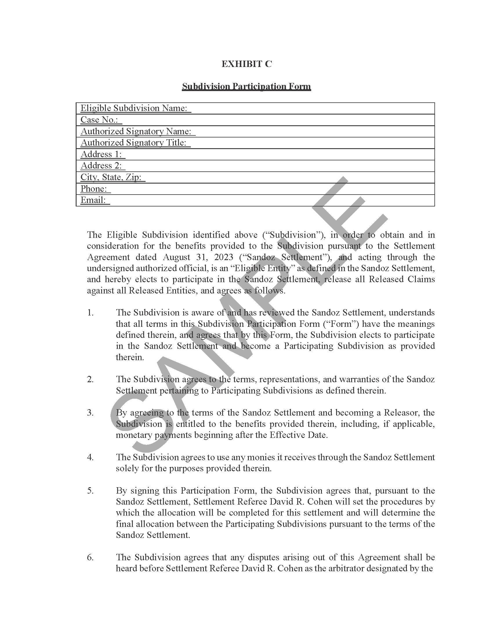
Exhibit A 